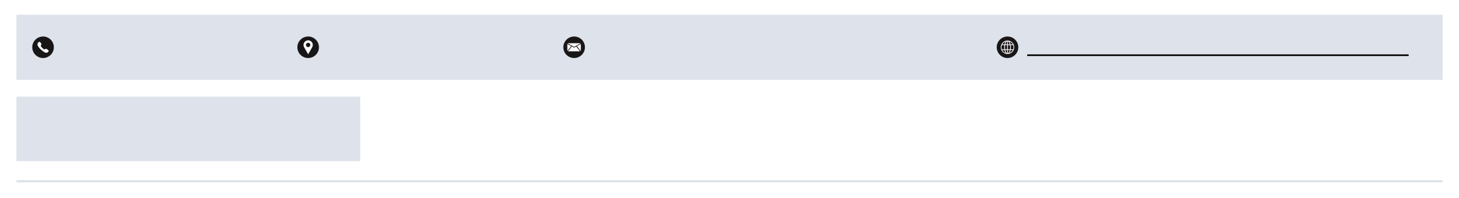
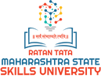
Akhielsh Moreshwar Jamadade
B.Tech - Computer Technology 

+91 8087668402 Pimple Gurav, Pune 2023000015@mssu.ac.in

PROFILE SUMMARY
https://www.linkedin.com/in/aditya- jagadale-50988b318/

I am a passionate Software Engineering student with a strong interest in AI, deep learning, and full-stack development. My journey combines technical problem-solving with creativity, as I also explore UI/UX design, Photoshop, and video editing to build impactful and user-friendly solutions.
EDUCATION

RATAN TATA MAHARASHTRA STATE SKILLS UNIVERSITY, PUNE  B. Tech in Computer Technology | 2023-(Third-Year Pursuing)
Rscoe`s Jspm Polytechnic Tathwade Pune | 2022-2023
Diploma of Education 66.59%  Maharshi Karve Stree Shikshan Sanstha | 2020-2021
SSC 66.60%
TECHNICAL SKILLS
Certifications and Achievements

Web Development: HTML, CSS, JavaScript, React, Node js
Programming Languages: Python, JavaScript Tools & Platforms: Git, GitHub, Visual Studio Code Creative & Design Tools: Adobe Photoshop, Figma
PROJECTS

Online Oxygen Management System

Website design to provide oxygen during medical emergency.

Deep Learning (Nov 17, 2025)
Deep Learning & Certification – Skillsoft
Artificial Intelligence (Feb 02, 2025) Information Technology Specialist – Certiport
LANGUAGES
English Marathi Hindi

